DEALS TO MANHATTAN

Manhattan is like nowhere else on earth. The mostly densely populated borough of New York City is widely regarded as the financial and cultural capital of the world. Visiting Manhattan is without a doubt an exciting, intriguing, and one-of-a-kind adventure. Book a trip to Manhattan via LaGuardia International, John F. Kennedy International Airport or Newark Liberty International Airport on Virgin America. Live it up at 35,000 feet with WiFi, on-demand entertainment, and more on every flight.

(MARKET IMAGE HERE)

Find Deals From These Cities

INSERT FARE GRID FROM / TO Version (if available!)

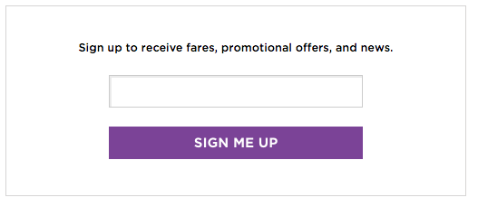   
Top Things To Do in Manhattan

To help narrow down the never-ending list of things to do in Manhattan, we’ve provided a few of the top activities to get you off to a great start.

* Explore Central Park. This 843-acre space is bursting with fantastic attractions, including numerous playgrounds, fountains, bridges, a zoo and famous dining options. While this park offers way more than you’ll be able to see in a short period, pick a few areas you’d most like to see and take the time to truly enjoy them.
* See an amazing performance at Jazz at Lincoln Center. While there, be sure to take in the amazing views over Central Park.
* Rent a bike and ride along the Hudson River Park. This is the perfect way to combine exercise and sightseeing!
* Stroll through SoHo, stopping at the eclectic boutiques and cafes throughout this historic neighborhood.
* If you find yourself in Chelsea, take a walk on the High Line. This old elevated train line has been turned into a beautiful linear park.

Travel Tips and Resources

[Must-Dos in Manhattan](http://content.time.com/time/travel/cityguide/article/0,31489,1843404_1843415_1843416,00.html)

[Manhattan Hotels](http://www.tripadvisor.com/Hotels-g60763-zfn29504-New_York_City_New_York-Hotels.html)

[Manhattan Restaurantshttp://www.timeout.com/newyork/restaurants/100-best-new-york-restaurants](http://www.timeout.com/newyork/restaurants/100-best-new-york-restaurants)

[Manhattan Shopping Guidehttp://www.frommers.com/destinations/new-york-city/663769](http://www.frommers.com/destinations/new-york-city/663769)

[Manhattan Nightlife and Entertainmenthttp://www.nyctourist.com/entertainment-nightlife.php](http://www.nyctourist.com/entertainment-nightlife.php)

[Manhattan Travel Tips](http://www.cnn.com/2013/04/08/travel/nyc-fake-local/)

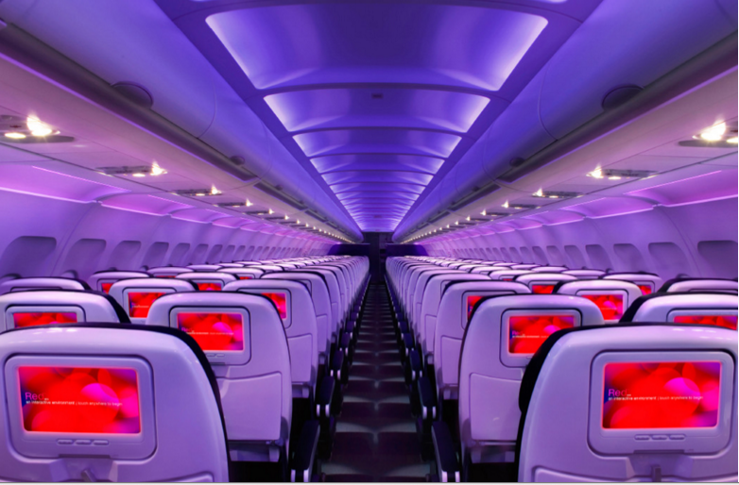

Main Cabin Main Cabin Select First Class

(add links to Cabin Class Pages)

Ready. Set. Fly.

Book your Mood-lit Ride to Manhattan.

Looking for flights to Manhattan? Book your flight with Virgin America to LaGuardia International, John F. Kennedy International Airport or Newark Liberty International Airport. You’ll enjoy on demand food ordering, in-seat entertainment, outlets at every seat, amazingly comfortable leather seats, mood-lit cabins, and much more. Get ready to love flying with us.

Take a Virtual Tour

Add Terms & Conditions